**Name:احمد محمد الطاهر احمد محمد الطاهر العزازي**

**B.N: 116**

**Topic: Artificial intelligence.**

**Applications beef:**

Artificial intelligence is one of important subjects we need to talk about. Artificial intelligence and deep learning expert Andrew Ng probably said it best when he described artificial intelligence as the new electricity. In saying this, he demonstrated his belief that AI will soon power most of our activities in society and business, drastically changing the ways we work and live. I believe that learning how AI works and understanding its implications for our lives is at least as important as learning to read and write. In other words, I recognize that we are now beginning to live in an era of AI, so it’s important to learn as much as we can about it early on.

**Screen shots:**

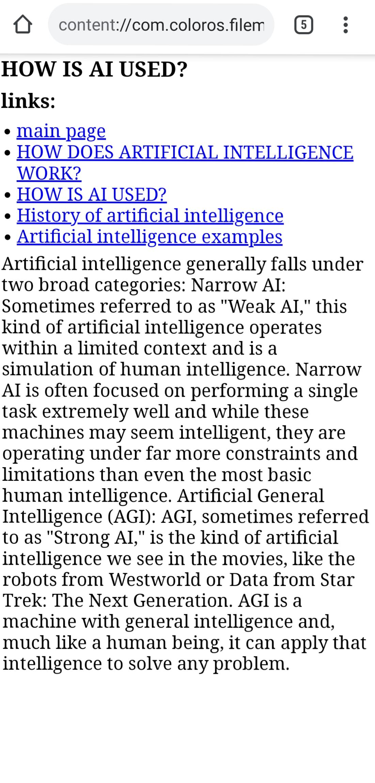

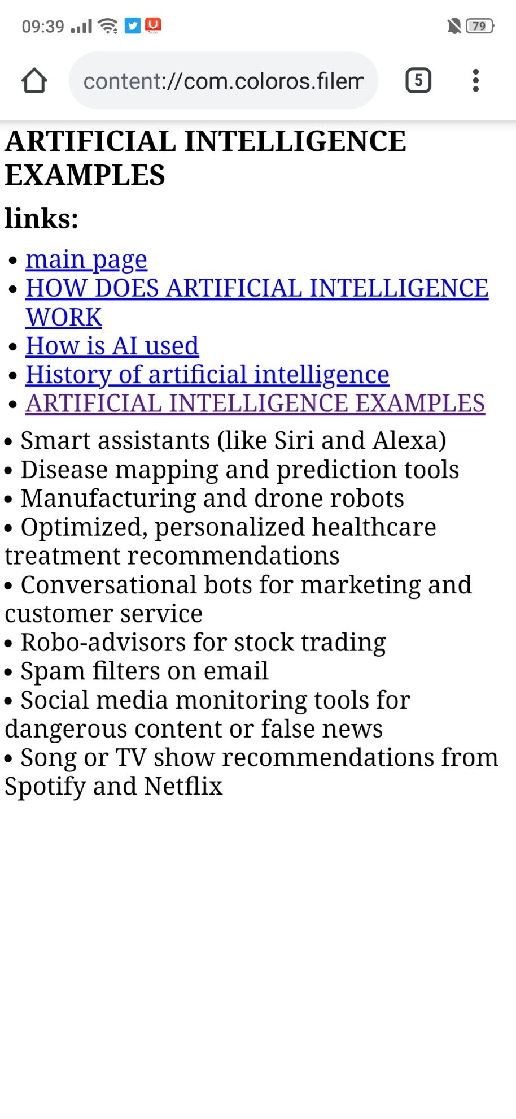**Source code:**

